Brussels, 1 February 2022

Fourth Survey on the use of State aid in the Covid-19 crisis

Data collection - Instruction file

The European Commission sent to your authorities on 1 February 2022 a letter about “Fourth survey and data collection on the use of State aid in the COVID-19 crisis” (HT.5938 comp(2022)782851). As anticipated in that letter, the survey contains also a data collection part, which aims at gaining up-to-date insights into the actual implementation of the State aid measures authorised by the European Commission.

The technical aspects related to the data collection are detailed below.

The European Commission kindly reminds your authorities that all COVID-19 State aid measures are subject to specific monitoring and reporting provisions and encourages a swift reporting of the information required under point 103 of the Temporary Framework of 19 March, amended on 3 April, 8 May 2020, 29 June 2020, 13 October 2020, 28 January 2021 and 18 November 2021 in the Transparency Award Module (TAM) or in the national transparency websites.

Transmission of the data
- The deadline to submit the data collection is Monday 28 February 2022 close of business.
- Member States are kindly requested to upload the Excel file “MS_-_Fourth_Survey_-_Data_Collection__State_aid_in_the_COVID19”, duly filled in https://ec.europa.eu/eusurvey/runner/TemporaryFramework_Survey_IV
- The password to access the survey was sent in a separate message on the 31 January 2022.
- Submissions via email will not be taken into consideration.
- You will be able to upload the file(s) and then save again your contribution.
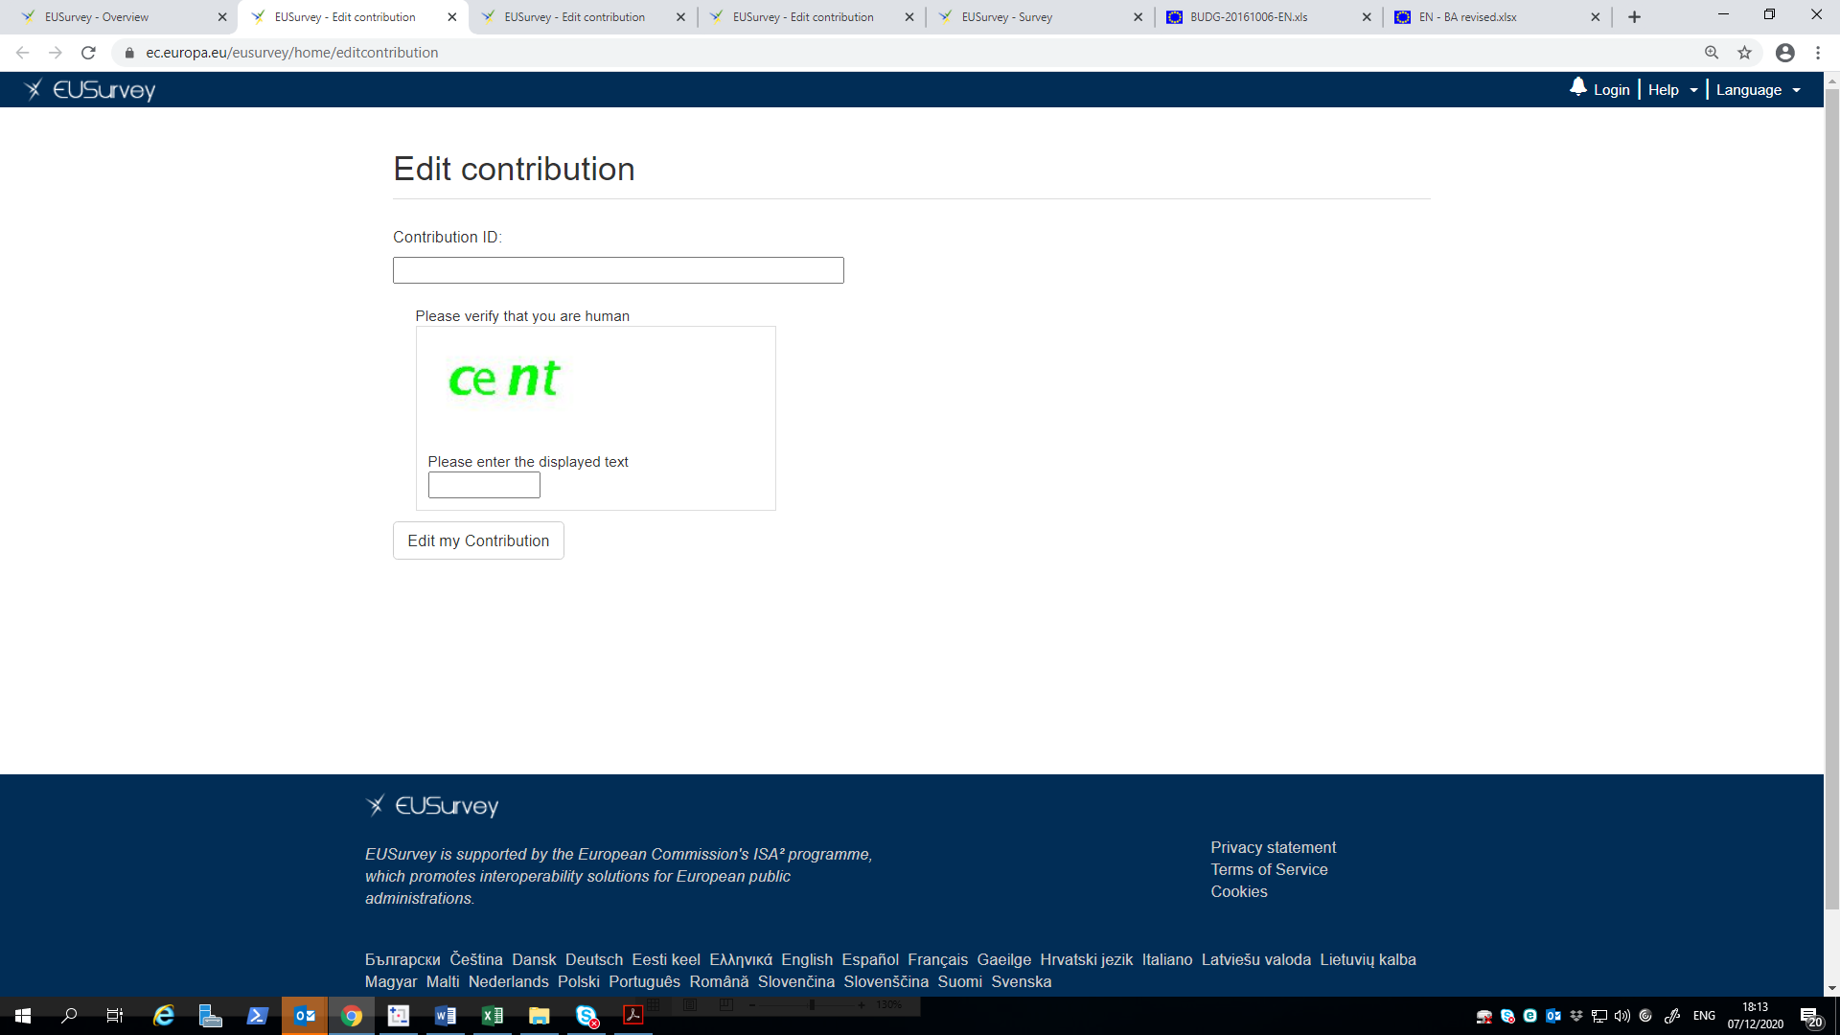

General instructions
Members States are to consult this set of instructions carefully for assistance in filling in the Excel file correctly.
- Data shall be provided using the dedicated template file MS_-_Fourth_Survey_-_Data_Collection__State_aid_in_the_COVID19 attached to these instructions.
- Data shall be provided for all COVID-19 State aid measures approved either under the Temporary Framework or directly under the Treaty. In order to facilitate this task, the template file is pre-filled with the list of State aid measures approved in your Member State. For each State aid measure, the template reports the State aid number as indicated in the text of the decision approved by the Commission, the title of the measure and State aid number of each amendment to the measure, if any. Therefore, if a measure has been subject to an amendment, the related data must be reported in correspondence to the initial measure.
- Data should be provided at aggregate level, covering all regions and all granting authorities.
- If it is not possible to provide aggregated data, Member States have the possibility to send disaggregated data to the Commission, for example by region or by granting authority. In this case, the Commission will take upon itself the task of aggregating the information.
- In case a piece of information is not available, please provide best estimates and mention it in the dedicated columns “Comments”, available in every data sheet. Aggregates can also be provided as orders of magnitude or in ranges.
- All monetary amounts shall be expressed in thousands of Euros.
- All monetary amounts shall be reported in number format.
- Data should always be reported in the appropriate cell, even if the requested information is missing. If a value is not available (meaning that best estimates are not possible), this should be reported as "n.a.". Values equal to zero should always be reported as zeros (i.e., only true zeros should be encoded as "0"). As a result, no cell in the data file should be empty.
- Any other feature of the specific data items that will be shared with the European Commission that is not covered by these instructions or by the template, and that is deemed to be relevant for their subsequent use, should be described by the Member State with the greatest possible detail in the dedicated columns “Comments”, available in every data sheet.

Structure of the Excel file
The file contains 13 data sheets:
- “Budgets – TF”: Please fill-in this data sheet with data relative to the total budget (i.e. amount committed in national budgetary laws) for all the measures approved under the Temporary Framework. This data sheet includes also a breakdown of the budget by section of the Temporary Framework. If the budget of a measure was revised downwards compared to what was originally planned, this should be clearly indicated in the dedicated column.
- “Budgets – Treaty”: Please fill-in this data sheet with data relative to the total budget (i.e. amount committed in national budgetary laws) for all the measures approved directly under the Treaty. If the budget of a measure was revised downwards compared to what was originally planned, this should be clearly indicated in the dedicated column.
- “Sectors”: This data sheet should be filled in with data relative to the amounts of aid granted, breakdown by sector (identified by the main section of the NACE code of the beneficiary), as of 31 December 2021 for all the legal bases.
- “Beneficiary type”: This data sheet should be filled in with data relative to the amounts of aid granted, breakdown by type of beneficiary (e.g. large undertakings, SMEs), as of 31 December 2021 for all the legal bases.
- “December 2021 - TF”: Please fill-in this data sheet with data relative to the amount of aid granted for all the measures approved under the Temporary Framework, from Commission's approval until 31 December 2021. This data sheet includes also a breakdown by section of the Temporary Framework. Amounts should be reported in nominal terms, i.e. nominal amount and not in gross grant equivalent. Data should refer to the indicated cut-off reference, i.e. 31 December 2021. If data is only available at a date before 31 December 2021, the reference date should be clearly reported in the file.
- “December 2021 – Treaty”: Please fill-in this data sheet with data relative to the amount of aid granted for all the measures approved directly under the Treaty, from Commission's approval until 31 December 2021. Amounts should be reported in nominal terms, i.e. nominal amount and not in gross grant equivalent. Data should refer to the indicated cut-off reference, i.e. 31 December 2021. If data is only available at a date before 31 December 2021, the reference date should be clearly reported in the file.
- “September 2021 - TF”: Please fill-in this data sheet with data relative to the amount of aid granted for all the measures approved under the Temporary Framework, from Commission's approval until 30 September 2021. This data sheet includes also a breakdown by section of the Temporary Framework. Amounts should be reported in nominal terms, i.e. nominal amount and not in gross grant equivalent. Data should refer to the indicated cut-off reference, i.e. 30 September 2021. If data is only available at a date before 30 September 2021, the reference date should be clearly reported in the file.
- “September 2021 - Treaty”: Please fill-in this data sheet with data relative to the amount of aid granted for all the measures approved directly under the Treaty, from Commission's approval until 30 September 2021. Amounts should be reported in nominal terms, i.e. nominal amount and not in gross grant equivalent. Data should refer to the indicated cut-off reference, i.e. 30 September 2021. If data is only available at a date before 30 September 2021, the reference date should be clearly reported in the file.
- “Guarantees Used”: Please fill-in this data sheet for each measure under which guarantees have been provided, with data relative to:
- The total nominal amount of guarantees, as of 31 December 2021;
- The total nominal amount of guarantees triggered as of 31 December 2021: guarantees that have been used, for instance in case of default of the beneficiary.

- “TF23ter”: Please fill-in this data sheet with data relative to the total amount of aid granted for all the measures approved under the Temporary Framework, from Commission’s approval until 31 December 2021. Then, please specify the total amount of aid granted through repayable instruments and finally the total amount of aid that although initially granted through repayable instruments has been converted into non-repayable instruments, as per Section 23ter of the Temporary Framework. Amounts should be reported in nominal terms, i.e. nominal amount and not in gross grant equivalent.
- “Ceiling3.1”: Please fill-in this data sheet for each measure under section 3.1 of the Temporary Framework, with data relative to:
- Whether the measure is applicable to undertakings active in the agriculture, aquaculture and/or fishery sectors;
- The total number of undertakings that have received aid under 3.1, as of 31 December 2021;
- The share of undertakings that have received the maximum aid as per point 22(a) or 23(a) of the Temporary Framework, as of 31 December 2021;
- The number of undertakings that have received more than 50% of the maximum aid as per point 22(a) or 23(a) of the Temporary Framework, as of 31 December 2021;
- The number of undertakings that have received more than 80% of the maximum aid as per point 22(a) or 23(a) of the Temporary Framework, as of 31 December 2021;
- “Previous data - TF”: This data sheet is pre-filled with the aid granted until 30 June 2020, 30 September 2020, 31 December 2020, 31 March 2021 and 30 June 2021 under measures approved directly under the Temporary Framework as elaborated by the Commission based on your submission(s) in the context of the first and the second survey. Errors and/or inconsistencies are highlighted in red and explained with a comment. Please fill out in case you want to amend the data already reported and correct errors and/or inconsistencies following the instruction in the comments, if present.
- “Previous Data - Treaty”: This data sheet is pre-filled with the aid granted until 30 June 2020, 30 September 2020, 31 December 2020, 31 Mach 2021 and 30 June 2021 under measures approved directly under the Treaty as elaborated by the Commission based on your submission(s) in the context of the first and the second survey. Errors and/or inconsistencies are highlighted in red and explained with a comment. Please fill out in case you want to amend the data already reported and correct errors and/or inconsistencies following the instructions in the comments, if present.
Any question related to the correct compilation of this data collection can be addressed to the email address: comp-covid@ec.europa.eu.

Section 4 of the Temporary Framework
https://webgate.ec.europa.eu/competition/transparency/public?lang=en
Aid granted is any aid arising from a legally binding commitment from the Member State to award the aid that can be invoked before the national courts. This differs from aid paid out.

